Historica
(AR/VR Powered Immersive Historical Learning Experience)

Atharv Sharma Information Technology
Acropolis Institute of Technology & Researh
Indore, India
sharmaatharv734@gmail.com
Khushi Agrawal
Information Technology Acropolis Institute of Technology
& Researh
Indore, India khushiagrawal281103@gmail.com

Jatin Rao Information Technology
Acropolis Institute of Technology & Researh
Indore, India
jatinpanwar877@gmail.com
Abhishek Rathore Information Technology
Acropolis Institute of Technology & Researh
Indore, India
yashabhishekrathore@gmail.com

Abstract— Historica is a web-based Augmented Reality (AR) platform designed to revolutionize the way users learn and interact with history. By combining immersive 3D environments, AI-driven avatars, and interactive maps, the application allows users to explore historical landmarks, events, and civilizations in a highly engaging manner. Unlike traditional history learning methods or hardware-dependent VR solutions, Historica provides seamless access through any browser, making it widely accessible. Features such as Time Travel Mode, AI-based scene reconstructions, and Quantum History simulations enable users to experience ancient eras with unprecedented realism. The project aims to enhance educational outcomes, preserve cultural heritage, and spark curiosity through technology-powered storytelling.
- Introduction
The Historica (Augmented Reality History Explorer) is a application that transports users back in time, allowing them to explore historical landmarks, events, and ancient civilizations through immersive augmented reality (AR) experiences.
Users simply select any location on a digital world map or point their camera at a physical landmark, and the app’s Time Travel feature will render a fully interactive AR scene from any chosen era. Whether it’s witnessing the grandeur of the Colosseum during gladiatorial games, the construction of the Pyramids of Giza, or the momentous events of the Mahabharata in Kurukshetra, the app brings history to life with remarkable detail and accuracy.

- PURPOSE
The primary purpose of the Historica project is to transform traditional history education into an interactive, engaging, and immersive experience using Augmented Reality and Artificial Intelligence. It aims to make historical learning accessible and exciting by allowing users to virtually explore ancient landmarks, interact with historical figures, and visualize significant events through a web-based platform— without the need for specialized hardware. The project also supports cultural preservation by digitally reconstructing lost worlds and showcasing heritage sites in their original glory.
Enhance Historical Learning: Provides an interactive way to study history with visual reconstructions, making education more engaging.
Virtual Exploration & Tourism: Enables users to experience historical sites remotely, bridging the gap between travel and digital learning.

- Literature Survey
The integration of Augmented Reality (AR) and immersive technologies into education has been widely explored over the past decade. Several studies highlight how AR enhances student engagement, memory retention, and contextual understanding, especially in subjects like history and geography. Projects like Google Expeditions, TimeLooper, and Civilisations AR by BBC have demonstrated the educational potential of AR in historical storytelling. However, most existing solutions either require expensive hardware (like VR headsets), are limited in geographic scope, or offer static, non-interactive content.

Academic research also supports that AI-driven personalization and interactive 3D visualization significantly improve learner motivation and comprehension. Yet, fully web-based solutions combining AR, AI, and historical simulation are still scarce, especially those focused on Indian heritage and accessible on low-end devices.

- Existing Problem
Traditional history learning methods—such as textbooks, documentaries, and classroom lectures—often fail to capture the imagination of modern learners. Key challenges include:
  - Lack of Engagement: History is often perceived as boring due to static and passive learning formats.
  - Limited Visualization: Students struggle to visualize ancient structures, cultures, and events accurately.

  - Hardware Dependency: Many AR/VR solutions require costly devices, making them inaccessible to most users.
  - Geographic Limitations: Few platforms offer a rich, interactive exploration of Indian or regional history.
  - Non-personalized Content: Most learning tools do not adapt to individual user interests or pace.

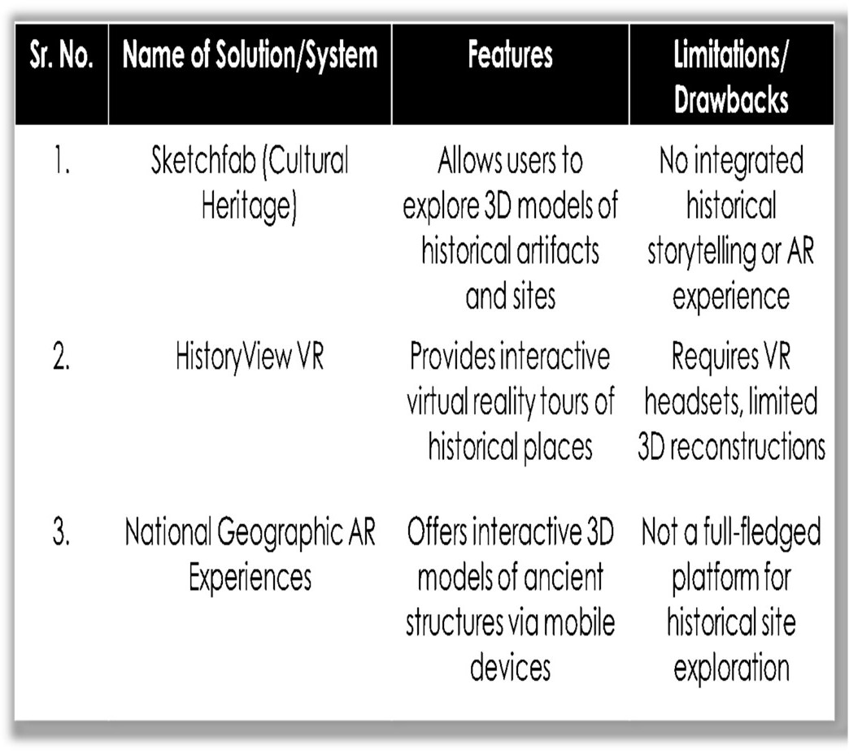
- Literature Review

Table.1 current Available Solutio

- Proposed Solution
The AR History Explorer is a web-based platform that provides interactive 3D models of historical sites, allowing users to visualize how these landmarks appeared in ancient times. Unlike existing solutions that require VR headsets or mobile apps, this website is accessible directly from a browser, making history engaging, immersive, and widely available.

  - High-Quality 3D Reconstructions – Users can explore detailed, historically accurate models with zoom, rotation, and annotations.
  - Web-Based AR Integration – Supports browser- based AR without extra applications.
  - Informative Historical Context – Clickable annotations provide historical facts and architectural details.
  - Accessibility & Preservation – No special hardware required, ensuring global reach and cultural heritage preservation.
- Flow Of Project

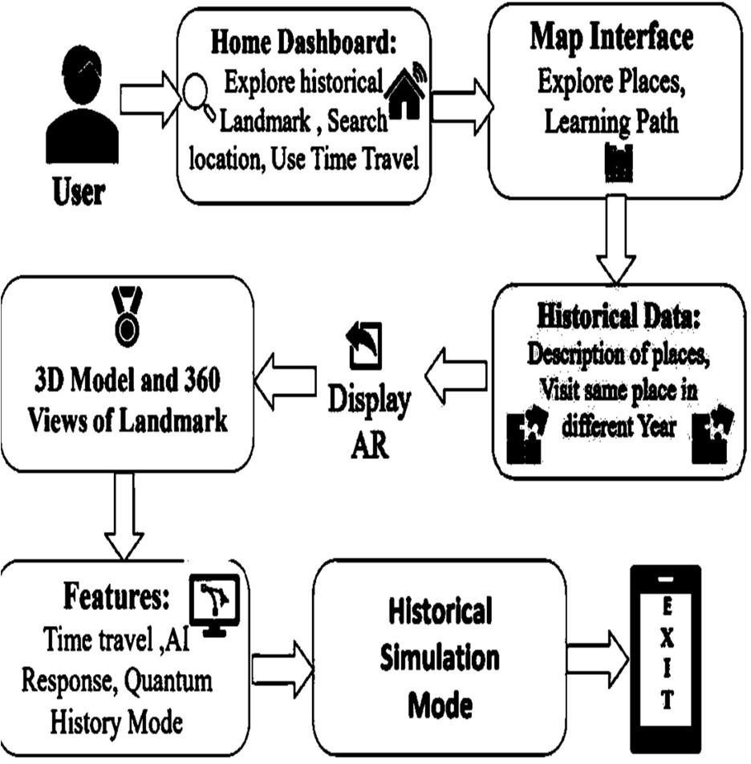

- Applictaion

- Education & E-Learning
Historica can be integrated into academic curricula to revolutionize history learning. By offering immersive 3D visualizations and AR-driven storytelling, it helps students understand complex historical events, architecture, and cultures in a highly engaging manner. It transforms passive learning into interactive exploration, improving retention and interest in the subject.
- Cultural Preservation
The platform digitally reconstructs lost monuments, ancient cities, and extinct civilizations using AI and AR. This serves as a virtual archive for future generations and aids in preserving intangible cultural heritage that may otherwise fade due to time, damage, or neglect. Historica supports global efforts in digital archaeology and virtual heritage.
- Tourism
Historica enhances tourism by turning real-world historical landmarks into interactive experiences. Tourists can point their device at a monument and view its past glory in augmented reality, complete with narrations and animated recreations. It also allows remote exploration, enabling virtual tourism for those who cannot visit in person.
- Museums & Exhibitions
Museums can use Historica to upgrade static displays into interactive AR exhibits. Visitors can interact with 3D models, converse with AI avatars of historical figures, and visualize ancient environments, significantly improving the educational value and appeal of cultural institutions.
- Historical Research & Simulation
The platform offers tools like Quantum History Mode and "What-If" simulations that enable researchers to explore alternate timelines, predict outcomes of hypothetical scenarios, and analyze the impacts of historical decisions. It opens new possibilities in digital humanities research.

- Public Awareness & Engagement
By making historical content entertaining and immersive, Historica sparks curiosity among general audiences, including casual learners. It bridges the gap between entertainment and education, encouraging more people to explore and appreciate historical knowledge..
References
- WebAR and 3D Visualization Technologies: Utilizes Three.js (threejs.org), A-Frame (aframe.io), and Model Viewer (modelviewer.dev) for rendering interactive 3D models and AR experiences in web browsers.

- Archaeological & Historical Research Sources: Based on UNESCO’s cultural heritage data (whc.unesco.org), academic research papers, and museum archives to ensure accurate reconstructions of historical sites.

- SketchFeb Official Documentation, https://sketchfeb.com/.

- CyArk (www.cyark.org)

- Shen, X., Shirmohammadi, S. (2008). Virtual and Augmented Reality. In: Furht, B. (eds) Encyclopedia of Multimedia. Springer, Boston, MA. https://doi.org/10.1007/978-0-387-78414-4_253

- Nur Fitria, Tira. (2023). Augmented Reality (AR) and Virtual Reality (VR) Technology in Education: Media of Teaching and Learning: A Review. International Journal of Computer and Information System (IJCIS). 4. 14-25. 10.29040/ijcis.v4i1.102.

- N. Godewithana, K. Jayasena, C. Nagarawaththa, P. Croos, B. Harshanath and J. Alosius, "Historical Places & Monuments Identification System," 2020 IEEE REGION 10 CONFERENCE (TENCON), Osaka, Japan, 2020, pp. 690-695, doi: 10.1109/TENCON50793.2020.9293882. keywords: {Chatbot;Feature extraction;Data visualization;Cultural differences;Augmented reality;History;Shape;Artificial Intelligent;Augmented Reality;Chatbot;Machine Learning;Natural Language Processing}

- Vîlcea, C., Popescu, L., & Niță, A. (2023). Historical Buildings and Monuments as Cultural Heritage In Situ—Perspectives from a Medium-Sized City. Heritage, 6(6), 4514-4526.
https://doi.org/10.3390/heritage6060239

- Qiu, X. yue, Chiu, C. K., Zhao, L. L., Sun, C. F., & Chen, S. jie. (2021). Trends in VR/AR technology-supporting language learning from 2008 to 2019: a research perspective. Interactive Learning Environments, 31(4), 2090–2113. https://doi.org/10.1080/10494820.2021.1874999

- H. Ardiny and E. Khanmirza, "The Role of AR and VR Technologies in Education Developments: Opportunities and Challenges," 2018 6th RSI International Conference on Robotics and Mechatronics (IcRoM), Tehran, Iran, 2018, pp. 482-487, doi: 10.1109/ICRoM.2018.8657615.
keywords: {Education;Resists;Virtual reality;Haptic interfaces;Sensor arrays;Astronomy;Augmented.reality; Virtual reality; Education; Technology ;Opportunities;Challenges},
- Kaluku, Moh Ramdhan & Pakaya, Nikmasari & Punu, Galang. (2022). Implementation of augmented reality on historical monuments in Gorontalo Province. Indonesian Journal of Electrical Engineering and Computer Science. 28. 559. 10.11591/ijeecs.v28.i1.pp559-566.

- Karaman, M.K. and Deniz, Önder 2025. The Role of VR, AR, and Artificial Intelligence in the Sustainable Preservation of Cultural Heritage: Social Media Marketing of Historical Sites, New Media Education in Turkey, and Their Contributions to SDGs. Journal of Lifestyle and SDGs Review. 5, 3 (Mar. 2025), e05260. DOI: https://doi.org/10.47172/2965730X.SDGsReview.v5.n03.pe0526

